Sample running file:

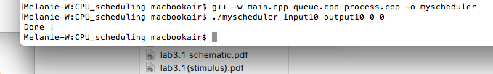Compile and run the program

This one is an example for RR algorithm

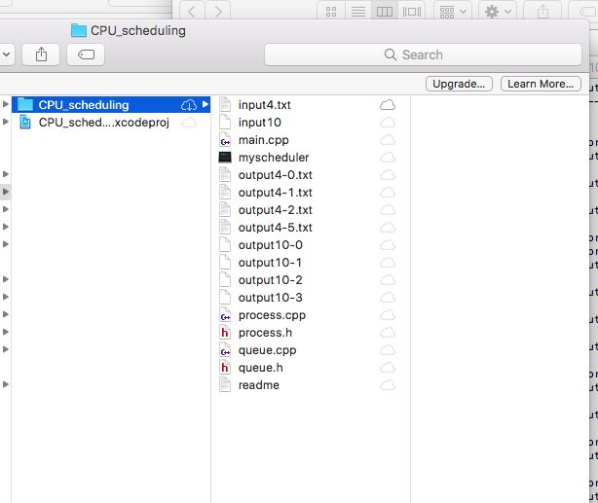The program then generates new file.

Sample output for input file (10 tasks)

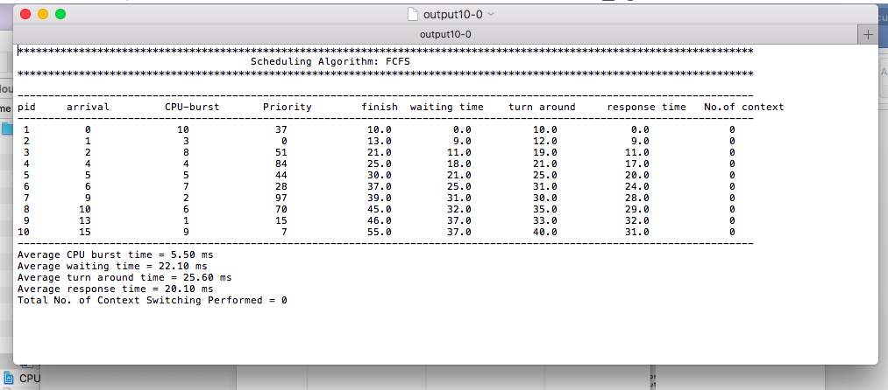FCFS algorithm

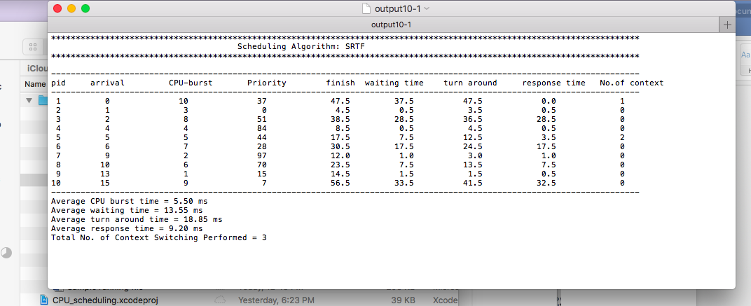SRTF algorithm

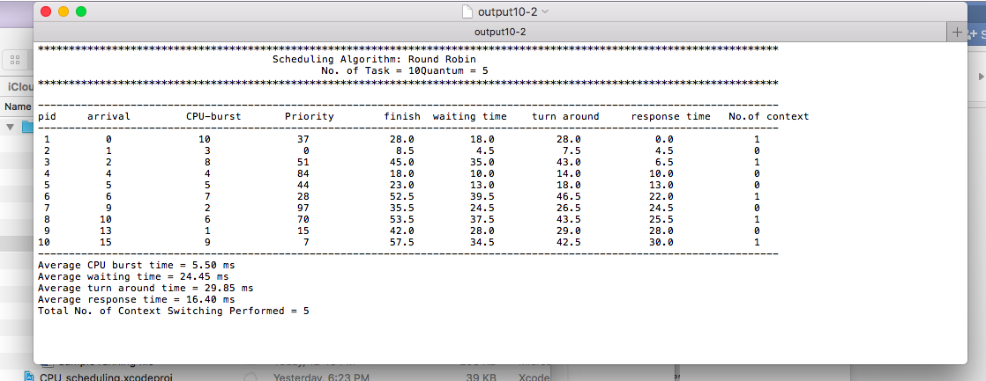RR (with quantum = 5)

PP

